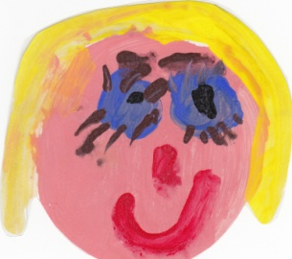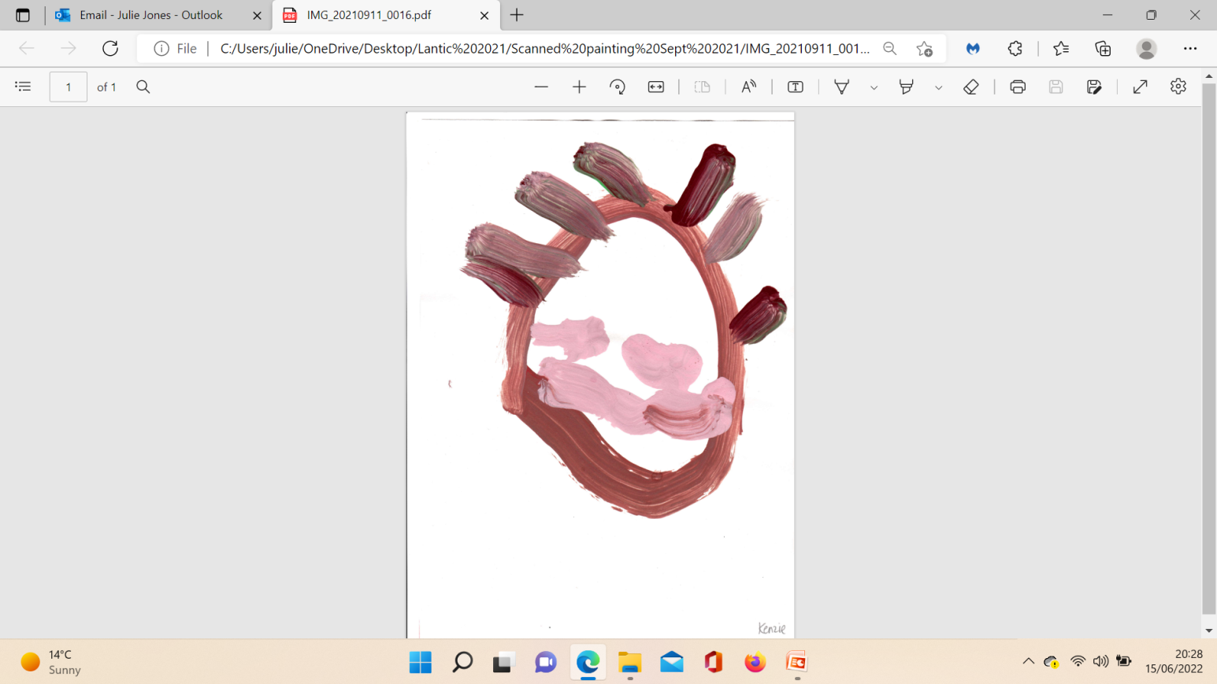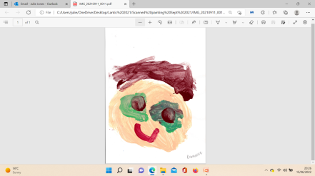 **Curriculum Rolling Programme - Nursery**

Our curriculum is heavily based on the children’s interests and is not a linear process. Optimal learning occurs from those opportunities that are of high interest to the children. Individual Tapestry journals evidence a discrete curriculum that differs between each child. This plan seeks to inform of the adult input sessions across the year and may take a different direction dependent on the interests of the children or important events that may be occurring in our community around us.

|  |  |  |  |  |  |  |
| --- | --- | --- | --- | --- | --- | --- |
|  | **Autumn 1** | **Autumn 2** | **Spring 1** | **Spring 2** | **Summer 1** | **Summer 2** |
| **Main theme:**  **Topic Focus** | We are special  What makes me special? | Autumn Season  Why do we celebrate? | People who help us  Who is a hero? | Animals  Whose footprints are these? | Growing food and farming  How does your garden grow? | Seaside  I wonder what is at the seaside? |
| **Characteristics of effective learning** | **Playing and Exploring**: I can explore and plan my ideas, I can try new activities based on my interests, I can make independent choices.  **Active Learning**: I keep trying, I achieve my goals, I am beginning to correct my mistakes by myself.  **Creating and Thinking Critically**: I can make links between ideas; I can check my progress and see how well I am doing; I have my own ideas. | | | | | |
| **Other possible themes based on children’s interests.** | Autumn  All about me  My family  My home  Our community  Relationships and feelings | Birthdays  Autumn  Diwali  Nursery Rhyme Week  Bonfire Night  Remembrance  Christmas | Valentines day  Chinese New Year  Superheroes  Looking after ourselves  Around the World  People who help us  Pancake day | Easter  St Piran’s day  World Book Day  International Women’s Day  Spring  Farm  Zoo  Jungle  Artic  Dinosaurs | Minibeasts  Growing  Lifecycles  Spring  Earth Day  Farm  Plant Lifecycles  May Day  World Bee Day | Holidays  Journeys  Lifeguards  Looking after the Ocean  Pirates  Mermaids  Local beaches  Rivers and Estuaries  Fishing  Weather |
| **Enrichment Activities:** | Making family books  Family Tea party  Black History Month (October)  Diwali-tasting foods from different cultures.  Harvest | Nursery Rhyme Week  Christmas performance  Christmas jumper/dinner day  Remembrance Day  Bonfire Night (Firefighter visit) | Community Heroes’ Day  Dress up as your favourite person that helps you.  Visit from police/nurse/vet/doctor  Chinese New Year parade | Role play flying to a different country.  Animal camera/ Virtual Zoo  Bird watching  Zoo trip  Marks Ark visit  World Book Day  Easter Bonnet Parade  St Piran’s Day | Tadpoles  Growing flowers  (Sunflowers/daisies)  Growing and releasing butterflies.  Vegetable patch in school allotment.  Cress heads  National Storytelling Week | Beach Trip  Water Day  Lifeguard/Coastguard visit  Beach/Water safety  World Music Day |
| **Personal, Social and Emotional Development**  Scheme: Jigsaw | Being Me in My World  Understanding my place in the class, school and global community | Celebrating Difference  Anti-bullying and diversity | Dreams and Goals  Goal setting, aspirations for yourself and the world and working together | Healthy Me  Self-esteem, confidence and healthy lifestyle choices | Relationships  Understanding friendships, family, other relationships, conflict resolution and communication skills | Growing and Changing  Including change in animals, humans and growth |
| **Communication & Language**  This is developed throughout the year through high quality interactions through daily group discussions, circle times, stories, singing and nursery rhymes. | Makaton signs:  Thank you  Hello  Sit down  Drink  Good morning  **Vocabulary focus**:  Greetings  Emotions  Nouns for objects in home setting and school setting  Adjectives to describe self and others  Sentences for preferences | Makaton signs:  Book  Look  Lunch/eat  **Vocabulary focus:**  Nouns for animals, seasons and weather  Adjectives for weather  Opposites hot -cold  Sentences to describe the concrete and abstract world around them | Makaton signs:  Mum  Dad  Home  Play  **Vocabulary focus:**  Nouns for professions and employment  Role play in professions with some specialist language eg, doctor or vet.  Sentences to command and to question | Makaton signs:  Dance  Toilet  Yes  No  **Vocabulary focus**:  Story structure and time. Long, long ago, In the beginning, after, next.  Sequencing sentences to tell a story | Makaton signs:  Sorry  Sleep  Finished  Baby  **Vocabulary focus:**  Nouns for food and eating such as cutlery, napkin  Descriptions of movement for mini beasts  Sentences to enquiry and introduce because… | Makaton signs:  Help  Little  Big  **Vocabulary focus**:  Scientific terms and tools such as magnifying glass, thermometer  Positional language on safari  Sentences to instruct movement |
| **Key texts, song and rhyme:** | Incredible you  What Makes Me A Me?  Special times/Night time’ Bonfire/Diwali  Stick Man  The Gruffulo  Homes  The same but different too  Peace at last  Look what I found in the woods  You choose  Calm down Boris  All welcome here | Elmer  Hedgehogs – How Can  I Help Roly the Hedgehog  Seasons - Tree  Mog in the Dark  Christmas Story  Can’t you sleep little bear?  One snowy night  Ten in a bed  Owl babies  Pants  Hats of faith | ‘People who help us’  Dinosaurs’  Transport/Travel  Naughty Bus  Dinosaurs  Harry and his Bucket Full of Dinosaurs  Going to the volcano  Superworm  Heroes all around the World | What the Ladybird Heard  Dear Zoo  Rumble in the Jungle  We’re Going on a Safari  We’re Going on a Bear Hunt  Giraffe’s can’t dance  Goldilocks and the Three Bears  Little Red Riding Hood  Farmyard Hullabaloo  The Three Billy Goats Gruff  The Three Little Pigs | On the Farm/In our Garden’  Old MacDonald Had a Farm  Jack and the Beanstalk  The Enormous Turnip  The Little Red Hen  Sam Plants a  Sunflower  Mad About Minibeasts  The very  Hungry caterpillar | Exploring Our World’  Under the Sea  Sharing a Shell  The Snail and the Whale  Commotion in the Ocean  Tiddler  The Singing Mermaid |
| **Reading and Phonics**  **(Birth to 3)** | I enjoy sharing books with an adult.  I can pay attention and respond to the pictures and words.  I enjoy songs and rhymes. I can tune in and pay attention. | I can join in with songs and rhymes, copying sounds, rhythm, tunes and tempo.  I can say some of the words in songs and rhymes.  I can listen to simple stories and understand what is happening with the help of pictures. | I can copy finger movements and other gestures.  I have favourite books and seek them out, to share with an adult, with another child or to look at alone. | I can sing songs and say rhymes independently, for example, singing whilst playing.  I can repeat words and phrases from familiar stories. | I can ask questions about the book. I can make comments and share my own ideas. | I can develop play around stories using props.  I can use the speech sounds p, b, m, w.  I can pronounce   * l/r/w/y * f/th * s/sh/ch/dz/j * multi-syllabic words such as ‘banana’ and ‘computer’.   I can notice some print, such as the first letter of my name, a bus or door number, or a familiar logo. |
| We use WellComm to identify all children’s needs with their language and understanding and use this to provide both whole setting activities and individual targeted intervention where there is an identified need. | | | | | | |
| **Reading and Phonics**  **(3 to 4)**  **Little Wandle Foundations used to support oral blending.** | Listening and Attention:  Tuning into sounds and auditory discrimination.  I can listen with increased attention to sounds.  I enjoy listening to longer stories and can remember much of what has happens. | Rhythm and Rhyme  Introduce Little Wandle Rhyme Time-Nursery rhymes.  I can sing a large repertoire of songs.  I can remember and sing entire songs.  I know many rhymes. I can talk about familiar books, and I can tell a long story. | Rhyme, syllables, and alliteration.  Little Wandle Oral blending games such as ‘Can you touch your?’ and ‘Name play’.  I can understand the 5 key concepts of print:   * print has meaning * print can have different purposes * we read English text from left to right and top to bottom * the names of different parts of a book such as front, back, cover, title and page. | Little Wandle ‘Blend from the box’ games. Foundations for Phonics-Spring 2  I am developing my phonological awareness so that I can:   * spot and suggest rhymes * count or clap syllables in a word, recognise words with the same initial sound. | Little Wandle ‘What’s in the box’ games. Foundations for Phonics-Summer 1 | Little Wandle ‘What’s in the box’ games. Foundations for Phonics-Summer 2  I can engage in extended conversations about stories, learning and new vocabulary. |
| **Writing**  **(Birth to 3)** | My co-ordination is developing. I can pass things from one hand to the other. | I can use large and small motor skills to do things independently such as managing buttons, zips and pour drinks.  I am starting to make marks intentionally. | I am developing manipulation and control as I explore different materials and tools. | I enjoy drawing freely.  I can express ideas and feelings through making marks, and sometimes give meaning to the marks I make. | I can add some marks to my drawings, which I give meaning to. For example “that says mummy”. | I can make marks on my pictures to represent my name. |
| **Writing**  **(3-4)**  **Little Wandle Foundations used for children to observe the graphemes used and support letter formation.** | I can use large-muscle movements to wave flags and streamers, paint and make marks. | I can use one- handed tools and equipment such as making snips in paper with scissors. | I can use a comfortable grip with good control when holding pens and pencils.  I am beginning to show a preference for a dominant hand. | I can draw with increasing complexity and detail, such as representing a face with a circle and including details. | I can use some of my print and letter knowledge in my early writing, such as writing a shopping list that that starts at the top of the page; I can write ‘m’ for mummy.  I can write some or all of my name. | I can write some letters accurately. |
| **Physical Development**  Get Set for PE programme  (Also see JIGSAW for PD links) | *Introduction to PE: Unit 1*  To learn the basic principles of a PE session such as finding a space, freezing on command, using, and sharing equipment and working individually, with a partner and group.  To take part in activities which develop fundamental movement skills such as running, jumping, and skipping.  *Fundamentals: Unit* 1  To develop fundamental movement skills, which include balancing, running, changing direction, jumping, hopping, and travelling.  To develop gross motor skills through a range of activities.  To learn to stay safe using space, follow rules and instructions to work independently and with a partner. | *Introduction to PE: Unit 2*  To explore structured movement through the topic of ‘everyday life’.  To recap basic principles from Unit 1 and continue to take part in activities which develop fundamental movement skills such as running, jumping, and skipping.  To play games to understand and use rules.    *Fundamentals: Unit 2*  To develop fundamental movement skills, which include balancing, running, changing direction, jumping, hopping, and travelling.  To develop fine and gross motor skills through handling equipment.  To stay safe using space and understand and follow rules and instructions.  To work independently and with a partner to complete tasks. | *Dance: Unit 1*  To develop expressive movement.  To explore space and use it safely.  To explore travelling movements, shapes and balances.  To choose actions as a response to stimulus.  To be given opportunities to copy, repeat and remember actions.  To introduce counting to help keep in time with music.  To perform to others and provide simple feedback.  *Ball skills: Unit 1*  To develop fundamental ball skills such as rolling and receiving a ball, throwing to a target, bouncing and catching, dribbling with feet and kicking a ball.  To develop fine and gross motor skills through a range of game play using a variety of equipment.  To work independently and with a partner. | *Gymnastics: Unit 1*  To develop basic gymnastic skills by creating shapes, balances, and jumps.  To begin to develop rocking and rolling.  To show an awareness of space and how to use it safely to perform basic skills on both floor and apparatus.  To copy, create, remember, and repeat short sequences.  To begin to understand using levels and directions when travelling and balancing.  *Games: Unit 1*  To develop an understanding of playing games.  To practice and further develop fundamental movement skills through games.  To learn to play by the rules, work with a partner and begin to understand what a team is, as well as learn how to behave when winning and losing. | *Dance: Unit 2*  To develop expressive movement.  To explore and use space safely.  To explore travelling actions, shapes and balances.  To choose actions in response to a stimulus.  To copy, repeat and remember actions.  To continue to count to help keep in time with the music.  To explore dance through the world around them.  To perform to others and provide simple feedback.  *Ball skills: Unit 2*  To develop fundamental ball skills such as throwing and catching, rolling a ball, using targets, dribbling with feet, kicking a ball, bouncing and catching a ball.  To develop fine and gross motor skills through a range of game play with balls.  To work independently and with a partner to develop decision making and using simple tactics. | *Gymnastics: Unit 2*  To develop basic gymnastic skills by exploring and creating shapes and balances, jumps and rolls.  To develop an awareness of space and how to use it safely.  To perform basic skills on both floor and apparatus.  To understand and use levels and directions when travelling and balancing.  *Games: Unit 2*  To practice and further develop fundamental movement skills.  To learn and develop these skills through a variety of games.  To learn how to work as a team, take turns, keep the score against an opponent and play by the rules. |
| Children develop their physical development through access to the outdoor provision for gross motor skills such as balancing, riding and ball skills, going up steps and apparatus, using alternate feet, hop and stand on one leg and hold a pose.  Children have daily adult led sessions to develop their gross motor skills which include yoga, big movement songs, dough disco, adult-led movement to music.  During continuous provision children have access to a range of resources to support their gross and fine motor skills including funky finger activities (cutting, weaving and threading, manipulating tweezers, pinching etc…), playdough, mark making and construction.  According to their individual needs children are supported to be increasingly independent with their own selfcare needs such as toileting and dressing. Children become confident in using a knife and fork having school dinners in the hall.  Children are supported to identify and make healthy choices with their food and drink choices during daily snack times. | | | | | |
| **Mathematics**  **(Birth to 3)** | I can combine objects like stacking blocks and cups.  I can explore colour and colour mixing.  To compare sizes using gestures and language ‘bigger/little/small’. | I can react to a change of amount in a group of up to 3 items.  To take part in finger rhymes with numbers. | I can compare amounts saying ‘lots’, ‘more’, or ‘same’.  I am developing counting-like behaviour, such as making sounds, pointing, and saying some numbers in a sequence. | I can count in everyday contexts, sometimes skipping numbers.  I can compare sizes using gesture and language.  Bigger/little/ smaller, high/low/tall, heavy/light. | I can complete inset puzzles.  I can build towers with a range of resources.  I can sing nursery rhymes.  I can talk about events in everyday life. |  |
| **Mathematics**: There will be many opportunities for mathematic skills to be revisited throughout the academic year to ensure children have a secure knowledge and understanding of mathematical concepts. | | | | | | |
| **Mathematics**  **(3 to 4)**  **Mastering the Curriculum Maths Scheme** | ***Colour, Match, Sort.***  To recognise the colours red, blue, yellow, green, and purple.  To recognise matching buttons and shoes and recognise and create matching towers.  To match number shapes, sizes, prints.  To sort by size, colour and shape. | ***Number/Pattern***  I can subitise, count and match numerals for the numbers 1 and 2.  I can subitise different sizes and patterns.  I can describe AB patterns from 2 different colours and predict what will come next in the pattern.  I can sort objects that are 2 or 3 different colours.  I can explore and create ABC patterns. | ***Number consolidation***  I can subitise up to 3 dots on a dice pattern.  I can count 3 and develop recognition of the numeral 3, what it looks like and what it represents.  I can recognise a triangle, square, rectangle and pentagon.  I can talk about the composition of numbers 1,2,3,4,5. | ***Number, Height and Length, Mass, and Capacity***  I can subitise, count and identify numbers using a five frame.  I can compare the height of objects using ‘tall’ or ‘short’ and ‘long’ or ‘short’.  I can use the balance scales to investigate objects which are heavier and lighter.  I can use capacity to explore containers which are full, empty, or nearly empty. | ***Sequencing, Positional language, More than/Fewer than, 2D-Shape, 3-D Shape***  I can sequence pictures from a nursery rhyme, daily routine and pictures from a familiar story.  I can discuss the position of objects using ‘on/under’, ‘in/out’, and ‘in front/behind’.  I can compare groups using more than and fewer than.  I can recall some properties of 2-D shapes.  I can recognise a cylinder and sphere and begin to talk about their properties. | ***Number Composition, What comes after? What comes before? and Numbers to 5.***  I can talk about the composition of numbers 3, 4, or 5.  I can explore numbers along a number line and identify the number before and after a given number.  I can count and identify the number of objects in a set to 5.  To explore the composition of numbers through songs, such as ‘5 Green Bottles’. |
| **Understanding the World**  **(Birth to 3)** | I can repeat actions that have an effect, for example rolling a ball down a pipe or dropping a stone in water and observing the splash. | I can explore materials with different properties. | I can make connections between the features of my family and other families. | I can explore different materials, indoors and outdoors. | I can respond to and explore the natural world around me. (In the setting and local places in Welly Walks). | I can notice differences between people. |
| **Understanding the World**  **(3 to 4)**  **Weekly use of Explorify to generate discussions about materials and the world.** | I am beginning to make sense of my own life story and my family history.  I can use all of my senses in hands on exploration of natural materials.  I can discuss the weather. | I can explore collections of materials with similar and different properties. | I can show an interest in different occupations.  I am developing positive attitudes about the differences in people.  I know there are different countries in the world and can talk about the differences I have seen in pictures. | I can describe the life cycle of an animal.  I can talk about the difference between materials and the changes I notice. | I can plant seeds and care for growing plants.  I can understand the key features of a plant life cycle. | I can talk about different forces and how they feel.  I can explore how things work.  I can understand the need to care for and respect the natural environment and all living things. |
| **Expressive Art and Design**  **(Birth to 3)** | I can show attention to sounds and music.  I can respond emotionally and physically to music when it changes.  I can move and dance to music.  I can anticipate phrases and actions in rhymes and songs like ‘Peepo’.  I can explore my voice and enjoy making sounds. | I can join in with song and rhymes, making some sounds.  I can make rhythmical and repetitive sounds.  I can explore a range of sound makers and instruments and play them in different ways. | I notice patterns with strong contrasts, and I am attracted by patterns resembling the human face.  I am starting to make marks intentionally.  I can explore paint, using my fingers and other parts of my body as well as brushes and other tools.  I can express my ideas and feelings through making marks, and sometimes give a meaning to the marks. | I enjoy and take part in action songs, such as ‘Twinkle, Twinkle Little Star’. | I am starting to develop pretend play, pretending that one object represents another, for examples holding a wooden block to my ear and pretending it’s a phone. | I can explore different materials, using all of my senses to investigate them.  I can manipulate and play with different materials.  I can use my own imagination as I consider what I can do with the different materials.  I can make simple models which express my ideas. |
| **Expressive Art and Design**  **(3 to 4)** | I can take part in simple pretend play, using an object to represent something else even though they are not similar.  I am beginning to develop complex stories using small world equipment like animal sets, dolls and houses, etc.…  I can make imaginative and complex ‘small worlds’ with blocks and construction kits, such as a city with different buildings and a park.  I can explore vegetable and leaf printing. | I can explore different materials freely, to develop my ideas about how to use them and what to make.  I am developing my own ideas and deciding which materials to use to express them.  I can join different materials and explore different textures.  I can use glue sticks and scissors when modelled by an adult. | I can create closed shapes with continuous lines and begin to use these shapes to represent objects.  I can draw with increasing complexity and detail, such as representing a face with a circle and including details.  I can use drawing to represent ideas like movement or loud noises.  I can show different emotions in my paintings, such as happiness, sadness, and fear etc. | I can explore colour and colour mixing.  I can listen with increased attention to sounds.  I can respond to what I have heard, expressing my thoughts and feelings. | I can remember and sing entire songs.  I can sing the pitch of a tone sung by another person. (Pitch match)  I can sing the melodic shape (moving melody, such as up and down, down, and up) of familiar songs.  I can create my own songs or improvise a song around one I already know. | I can play instruments with increasing control to express my feelings and ideas. |
| School Drivers  Evidenced in our daily practice, ethos and adult-led sessions | DRIVER 1  To promote and celebrate diversity within the school culture and beyond. An “all welcome” ethos with strong consideration for exposure to images and role models which expand the pupils experience and challenge stereotypes. | | DRIVER 2  To promote mental health for all with an emphasis on outdoor learning and immersion in natural environment. | | DRIVER 3  To ensure exposure for all to events and learning with high cultural capital, especially for the pupil premium cohort. | |

